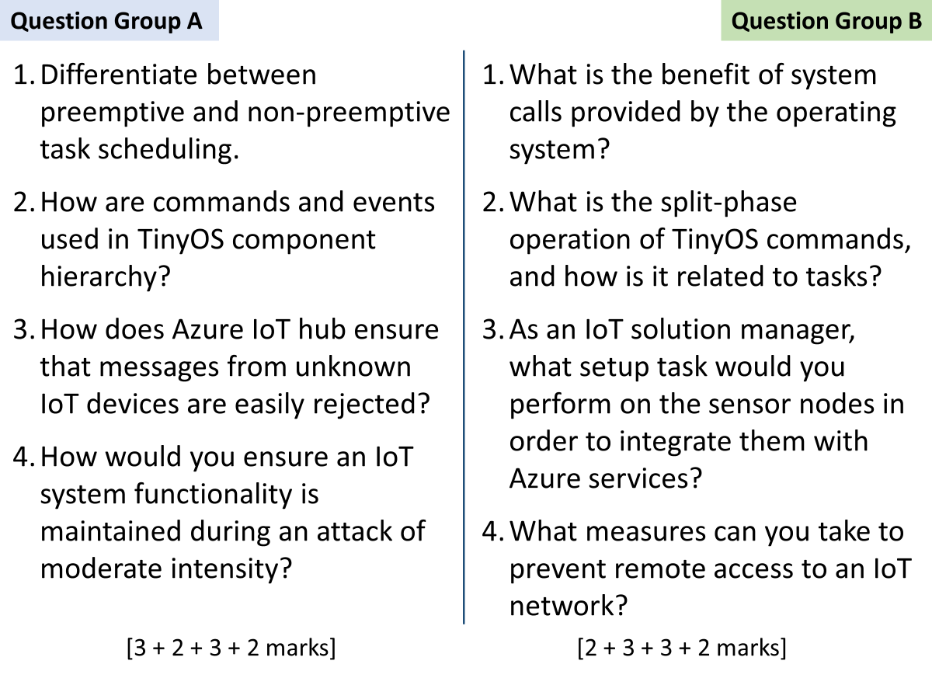

A

1

In non-preemptive scheduling, a task is executed to the end, it can’t be interrupted by another task. Preemptive scheduler means a task of higher priority may interrupt a task of low priority.

2

higher-level components issue commands to lower-level components

lower-level components signal events to higher-level components

3

Firstly, all valid devices need to be provisioned. Then when a device connects to hub, it goes through the stages of authentication and attestation to prove its identity. If any of these steps fail, hub treats the device as unknown and rejects its data.

4

By keeping a redundant version of each critical component.

By allowing graceful degradation such that under an attack, system can continue to work with manual control instead of automatic operation.

---

B

1

Syscalls hide the complexity of hardware and provide a uniform method for user apps to perform hardware i/o.

2

When a command function call is made, the callee creates a task (that will be scheduled by OS sometime later) and returns immediately.

Later when the task is complete, the callee signals an event for the caller.

3

First, the nodes need to have Azure SDK installed. Secondly, they need to be configured with the correct authentication & attestation keys which were provided by Azure during device provisioning.

4

using unidirectional gateways, firewalls, dedicated authentication mechanisms, and multiple layers of protection.